Hence, we propose the Tree Mover’s Distance (TMD), a pseudometric on attributed graphs that considers both the tree structure and local distribution of attributes. It achieves this via a hierarchical optimal transport problem that defines distances between trees.

First, we observe that the TMD captures properties that capture relationships between graphs and common labels: a simple SVM based on TMD performs competitively with standard GNNs and graph kernels on graph classification benchmarks.

We found TMD correlates well with the performance of GNNs under distribution shifts.

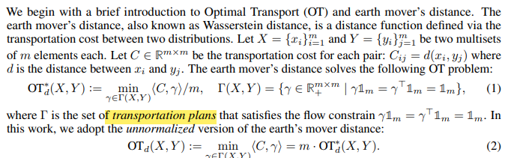

If depth-L computation trees are the same for two nodes, they share similar neighborhoods up to L steps away. Therefore, an intuitive way to compare two graphs is by measuring the difference of their nodes’ computation trees [44, 53].

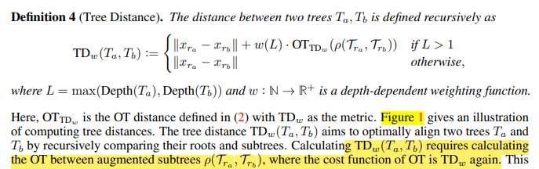

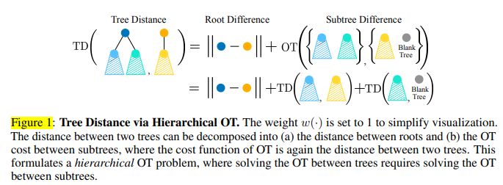

From Tree Distance to Graph Distance

